Health Care Analytics

Assignment – 2

Visual Analytics for Healthcare

Healthcare data visualization is one of the crucial stages of data analysis.

What is visual analytics in healthcare 2023?

The 2023 Workshop on Visual Analytics in Healthcare will cover a range of topics on the design, implementation, deployment, evaluation, and abstraction of visual analytics methods, including (but not limited to): Clinical care: Prescription drugs and drug-drug interactions.

**The most popular deep learning algorithms are:**

* Convolutional Neural Network (CNN)
* Recurrent Neural Networks (RNNs)
* Long Short-Term Memory Networks (LSTMs)
* Stacked Auto-Encoders.
* Deep Boltzmann Machine (DBM)
* Deep Belief Networks (DBN)

I Have Used Deep Learning Regresion Algorithm in this code

import pandas as pd

import numpy as np

import matplotlib.pyplot as plt

import seaborn as sns

import sketch

from dataprep.eda import plot, plot_correlation, plot_missing

pd.set_option('display.max_columns', 50)

%matplotlib inline

from google.colab import drive

drive.mount('/content/drive')



df = pd.read_csv('/content/insurance (1).csv', dtype={'sex':'category', 'smoker':'category', 'region':'category'})

df.info()

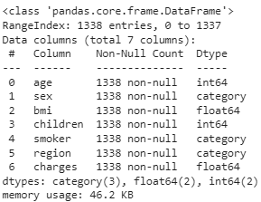

plot(df)

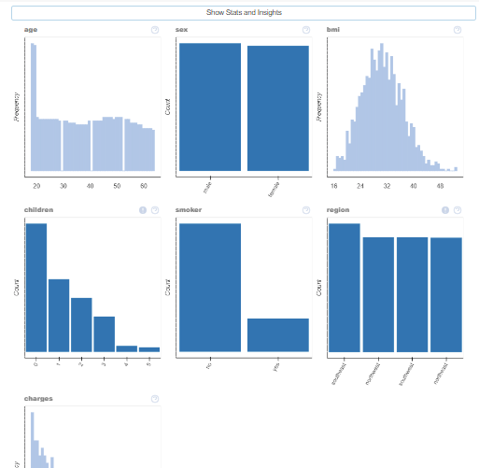

sns.catplot(data=df, x='age', y='sex', palette='icefire', hue='smoker',row='children', sharex=False)

plt.show()

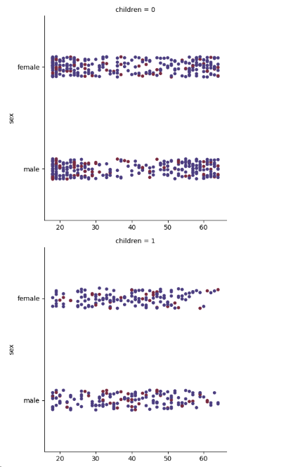

plot(df, 'age')

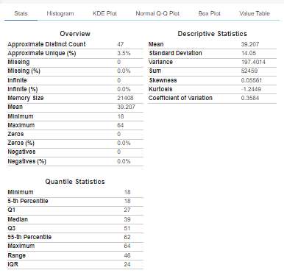

plot(df, 'smoker')

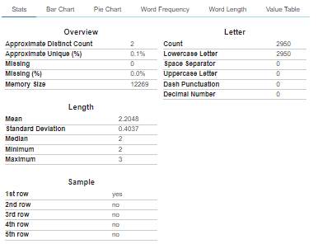

import plotly.express as px

fig = px.box(df, x='sex', y='charges', color='children', facet_col='smoker')

fig.show()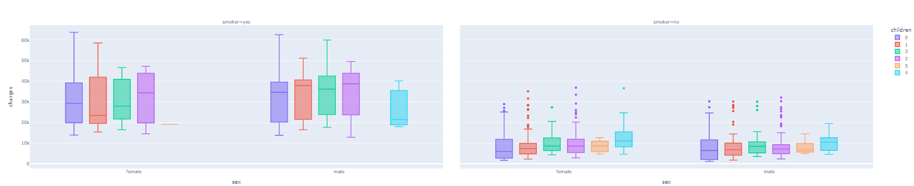

fig = px.scatter_3d(df, x='age', y='children', z='charges', color='sex')

fig.show()

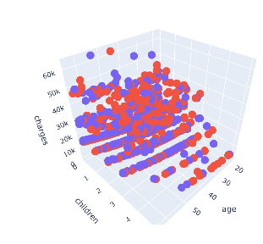

from pycaret.regression import *

s = setup(data=df, target='charges', session_id=123, normalize=True, normalize_method='minmax')

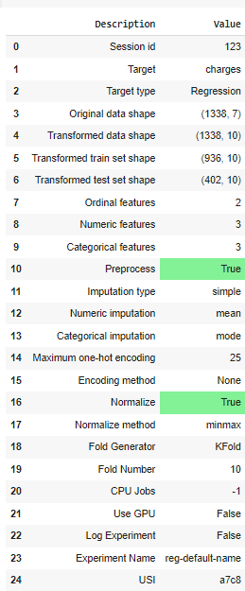

best = compare_models()

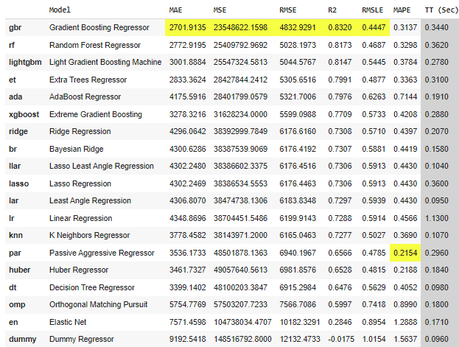

tuned_best = tune_model(best)

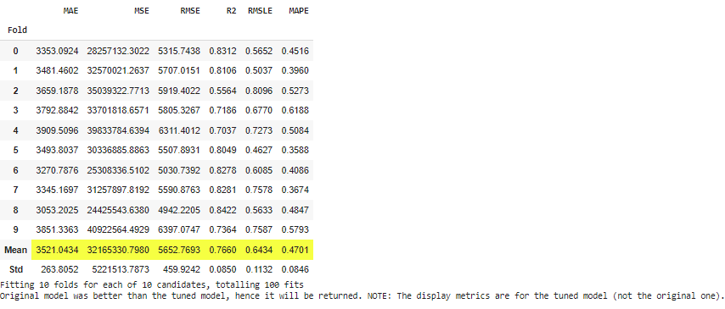

from scipy import prod

result = predict_model(tuned_best, data=df)



result.head()

